Kenneth LANCE RAFVR
Date of Birth: 1921
Parents; Son of Harry Percy Johnson and Winifred Rose Lance of Ferring
Sussex
School Years: 1933-1939 Chichester High School for Boys
Form Prize 1935 – 1938
Oxford School Certificate July 1938
Civil Occupation: Civilian Occupation: ‘The Martlet’ ‘Old Boys News’ December 1940
K.Lance (1933-1939) at St Patrick’s Hall, Reading University been awarded a West Sussex Agricultural Scholarship for 1940-1941
‘The Martlet’ December 1943 ‘Roll of Service’ Sgt W.O/A.G. R.A.F.

Armed Forces Record

Service Rank: Sergeant
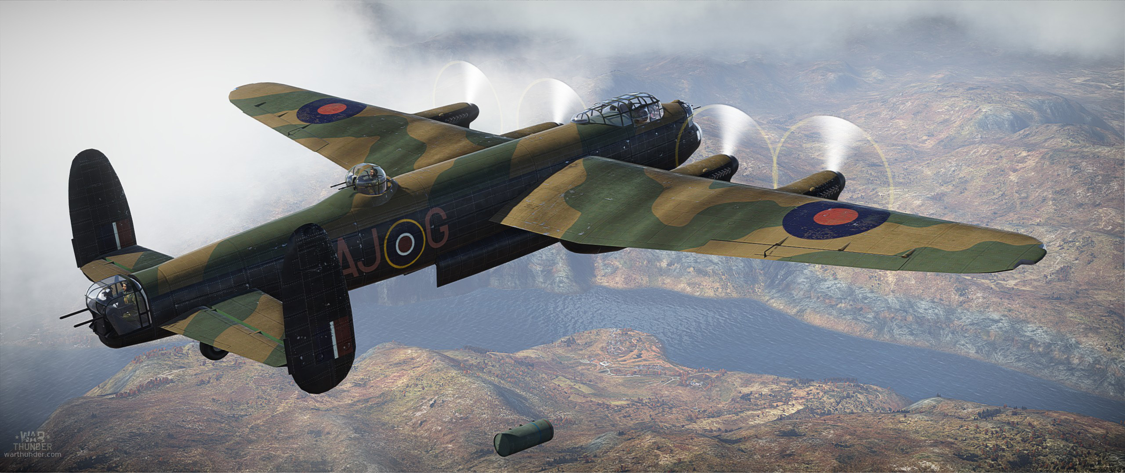
Service Number: 1320387
Service Record: No. 10 Squadron
Service Base: RAF Melbourne
Date of Death: 22/23.11.1943

Handley Page “Halifax”

The Bomber Command War Diaries – Martin Middlebrook/Chris Everitt
22/23 November 1943 - Night
Berlin
746 Aircraft – 469 Lancasters, 234 Halifaxes, 50 Sterlings, 11 Mosquitoes.
Losses 26 aircraft – 11 Lancasters, 10 Halifaxes, 5 Sterlings – 3.4 percent of the force
This was the greatest force sent to Berlin so far. Bad weather again kept most of the German fighters on the ground and the bomber force was able to take a ‘relatively-straight’ route to the target without suffering undue loss. Siemens Factory and Tank Factory destroyed. Heavy civilian casualties.
Bomber Command Losses of the Second World War – W.R. Chorley
22-23 November 1943 – 10 Sqn – Halifax II – JD146 ZA-Y – Group 4 – Op: Berlin
F/O Pont Sgt J. McMillan
Sgt T.H.R McKeag Old Boy Sgt K. Lance – WO/AG
Sgt A. Buchan F/O M.F. Baxter
T/o 1654 Melbourne. This aircraft lost without trace.

Commemorated
Chichester High School for Boys
St Nicholas Church – Middleton-on-Sea – West Sussex
Runnymede – Panel 156
International Bomber Command Centre – Lincoln - Phase 2 Panel No. 196

