Allan Reginald Coombes

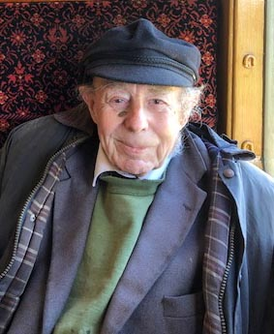

Those members who were on the Isle of Wight Summer trip in 2019 will remember Allan Coombes and his daughter Anne- Marie Bannister who jopined us on that sunny day. Sadly Allan died on the 6th June in Bournemouth. He was born in Portsmouth on 21st August 1936. Colin Snook adds that “He and I were born in Portsmouth about a mile apart. Both families had to evacuate due to the Luftwaffe raids”. Allan was a pupil at Chi High from 1948 to 1956.

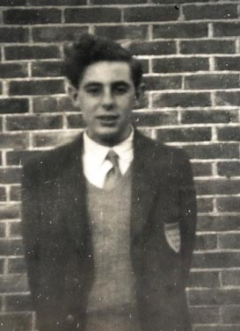
Anne-Marie adds “Dad had an insatiable thirst for knowledge. He put this down to the advice of his history teacher A G Lawton at Chichester School, who taught him: ‘The most important word in the English language is “Why?”
The following photographs show Allan at school.

He was active in The Blake/Scripture Society. In the 1955 Blake Society report which he wrote he says “We have had some good speakers this term, with the exception of the secretary (himself), who severely tried the patience of the faithful few when he spoke on the church behind the Iron Curtain.

Later in the 1956 December Martlet there is an entry “we remember with gratitude A.R.Combes (VIAU), our secretary, who actively supported so many school activities from music to archaeological excavations during the holidays…….we cordially wish him every success in his career”. Interestingly his name was spelt Combes not Coombes.

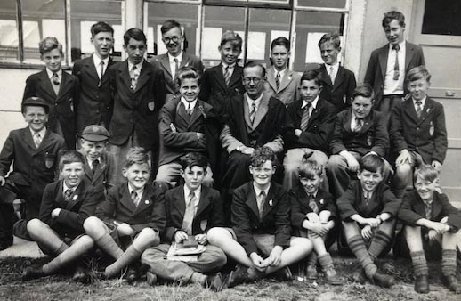
Tony Wheatley describes the photos thus:
“The photo is c1949 portraying what looks like “The Bug Club” of that era outside the Biology lab. I was not a member and thus not in the picture.
Back row, second on left, is Pelham, son of Percy Pelham.
On Bogey Murch’s right is Derek Horton who played first violin in the school orchestra whom I last met, c5 years ago, when he was selling furniture in North Street.
Front row, first left, is Monkey Watson, son of Monkey Watson.
Allan is front row, third from left, looking very handsome.
Front row, fifth left, is Holland, son of Dutch Holland.
Front row, far right, is possibly Tony Jupp.
I recognise faces of some of the others but unfortunately not names.”
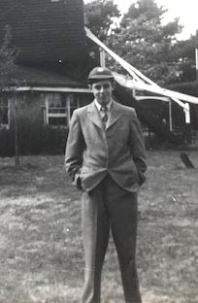
After leaving school after A Levels, he went to Bristol University on a West Sussex State Scholarship to study Political History. On completing his studies Allan had hoped to ultimately practise as a solicitor, circumstances led him into academic teaching at the Polytechnic of Central London (now University of Westminster), Holborn College and universities across Scandinavia. As a brilliant communicator this truly was his natural vocation and to the gain of many, many students. He cared deeply for all his students and colleagues and made himself endlessly available to them. His considerable intellect also encompassed maritime and medieval history, theology, current affairs and of course law. He read voraciously and admitted that whilst humouring his partner Adrianne by attending a live performance by Katherine Jenkins on a cruise, he spent the performance mentally conjugating Latin verbs. He was still improving his Latin a few days before he died! Education was not only a gift, but to him, a fundamental human right. He was curious about everything (except sport perhaps which he considered anathema).

Allan’s charm was a quality many remember him for. He was interested in all kinds of people and he could – and did - strike up a conversation with anyone, with charm, wit and flair – and always a cigarette. Despite having absolutely no interest in his appearance, with his beautiful diction and manners, he was the perfect gentlemen to anyone he encountered without a trace of snobbery and he always said that one should treat a laundry woman or a duchess just the same – and he did.

Faith was the central pillar of Dad’s life. Born an Anglican he converted to the Roman Catholic Church around 1960, largely thanks to the writings of St John Henry Newman. He would say, ‘Nothing is impossible to God’ and he absolutely believed this. Anne-Marie adds that “Faith, Family and Friends were his “Holy Trinity”.

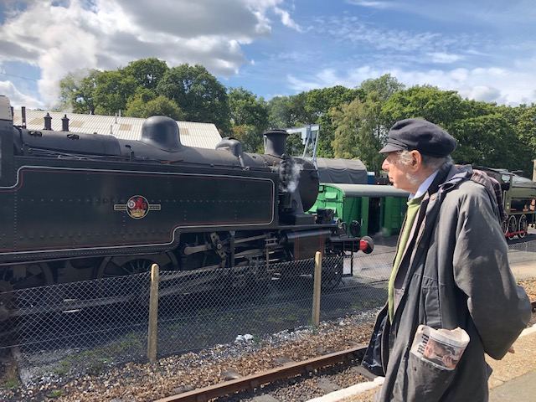
He loved his family – Anne-Marie and son-in law Chris, son Dominic and grand-children Oliver and Dominic and his partner for the last 30 years Adrianne. He was a member of for Paddle Steamer Preservation Society in which he was heavily involved in for 40+ years, including being London branch chairman for a time and in recent years an active member of the Wessex branch committee. His interest in the locomotives and trains on the Isle of Wight was manifest. Allan always stressed the importance of the Old Cicestrians to him. He very rarely missed the Christmas lunch even though every year it clashed with the one for the Paddle Steamer Preservation Society! He was committed to both but felt that the OC lunch was the rare opportunity to see many old school chums and he would make huge efforts to get there, checking for railway engineering works about a month in advance!

Bill Allen OC Chairman

