From: David Saunders <d.b.saunders@ncl.ac.uk>
Subject: 1962-70
Message Body:
“Just to thank Alan H. J. Green for his book 'Chichester in the 1960s', which I came across recently by chance and couldn't put down. Although I have lived in Newcastle upon Tyne since late 1978 and have been in Chichester only twice in all time (in 1994 and 2004), the city will always be home to me because it was there I spent my formative years. My parents moved there from Chelmsford in 1961 and I was at Central Junior Boys in New Park Road for the school year 1961-2 before going to the High School, where I stayed until the very beginning of 1970 (I did the third-year sixth, i.e. the autumn term of 1969-70). I'm afraid I don't remember Alan, but I should and perhaps would if I could picture him, because to judge by his book we were at CHSB (and Central Junior) at exactly the same time. Also my family lived first in Chapel Street in a little place attached I think to the clinic there (my Dad worked in the Health Department at County Hall) and then at 63 Cedar Drive which was in the bit of that road with the cedars that juts into Parklands Road, i.e. both places which were/are quite near Orchard Street where Alan seems to have been brought up. My friend John Bassett who was in my year at school lived in Orchard Street. I used to walk past Mayor Selsby's electrical shop on Westgate on my way to school. I witnessed the demise of Westgate Fields. I was in the same class at CHSB as Everard Meynell, whom Alan mentions in his book. I was a denizen of the Wessex Bookshop. My brother took drugs at the El Bolero. Others in my class included Steve McGairl, Phil Gates, Denis Pattison, Paul McCormick, Ian Haynes, Clive Ford, etc etc. If you could possibly pass this message to Mr Green and he could bear to contact me, I should be absolutely delighted.”

David omits to add he was School Captain in 1969!

At Oxford David achieved a BA Modern History 1973 (1st class); MA 1977; DPhil 1978
and became a Russian History academic. In a long and distinguished career David includes the Harold Salvesen Junior Fellow, University College, Oxford (1977 - 31 December 1978) Lecturer in History, University of Newcastle upon Tyne 1 January 1979 - 1988, Senior Lecturer 1988-95, Reader 1995-9, Professor 1999-2017. His publications, teaching and administrative work and media work included - Interviewee on BBC Radio 3, Radio 4, World Service, Russian Service, and local; consultant on a number of occasions to Channel 4 and Yorkshire-Tyne Tees Television; adviser in various connections to local journalists

David added that “I owe what little I achieved more or less entirely to Chi High, esp to Mark Evans the Russian master but also to Michael Holmes my History master and Mr Collins (English), Mr Ayling (Music), Messrs Reeves and Smedley (French), and Messrs Gahan and May (Latin). I wasn't very good at Science I'm afraid!”

There follows some photographs of his time at Chi High.

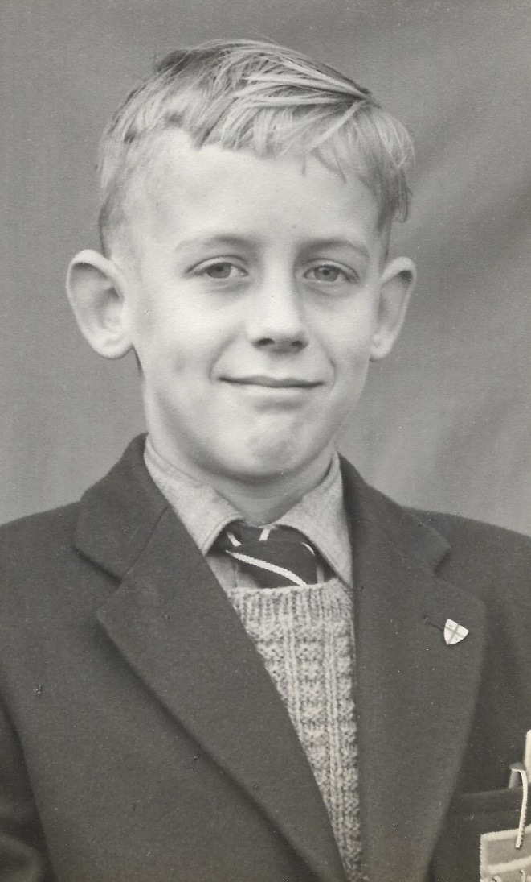

Davis, first year in 1962 - Trevor Hamilton who later taught at the school was our form prefect for part of that first year and David Wood the famous actor and writer was Deputy Head Boy.

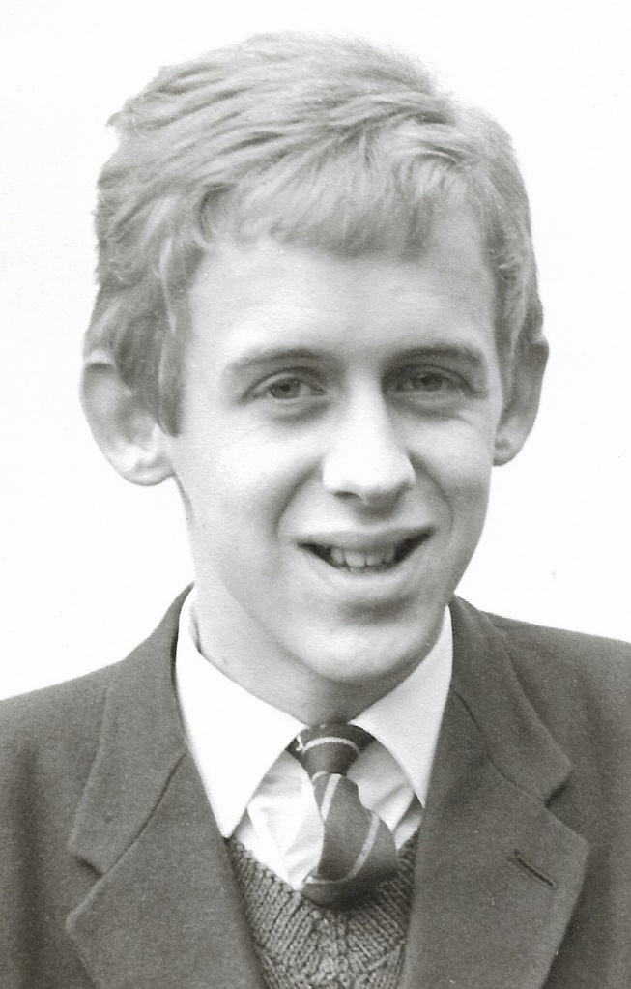

David in November 1966 when he was fifteen and in the fifth form after getting O-levels earlier that year in Latin, English, French, and Maths.

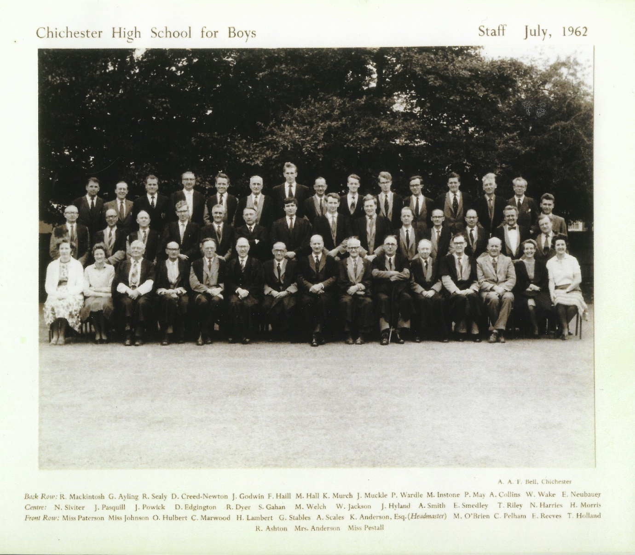

The staff in July 1962 (which, mysteriously, was two months before I entered the school!)

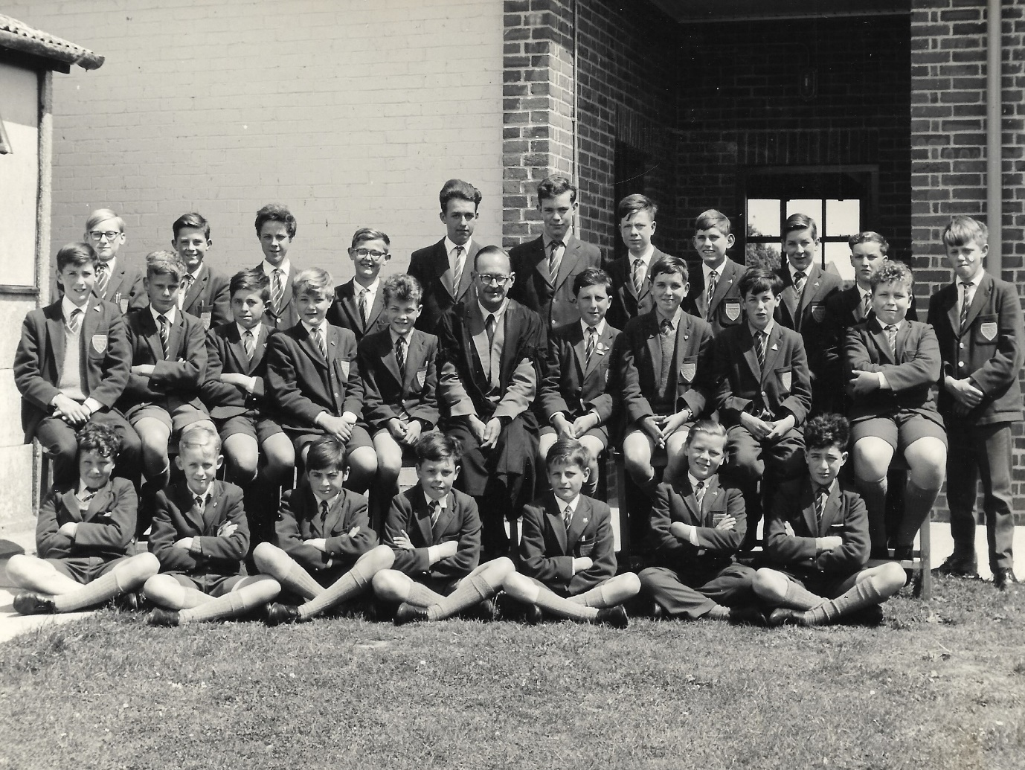The Bug Club in the summer of 1963 (David second from the left cross-legged on the ground). Mr Murch lived along the road from us in Cedar Drive and I have nothing but fond memories of him.

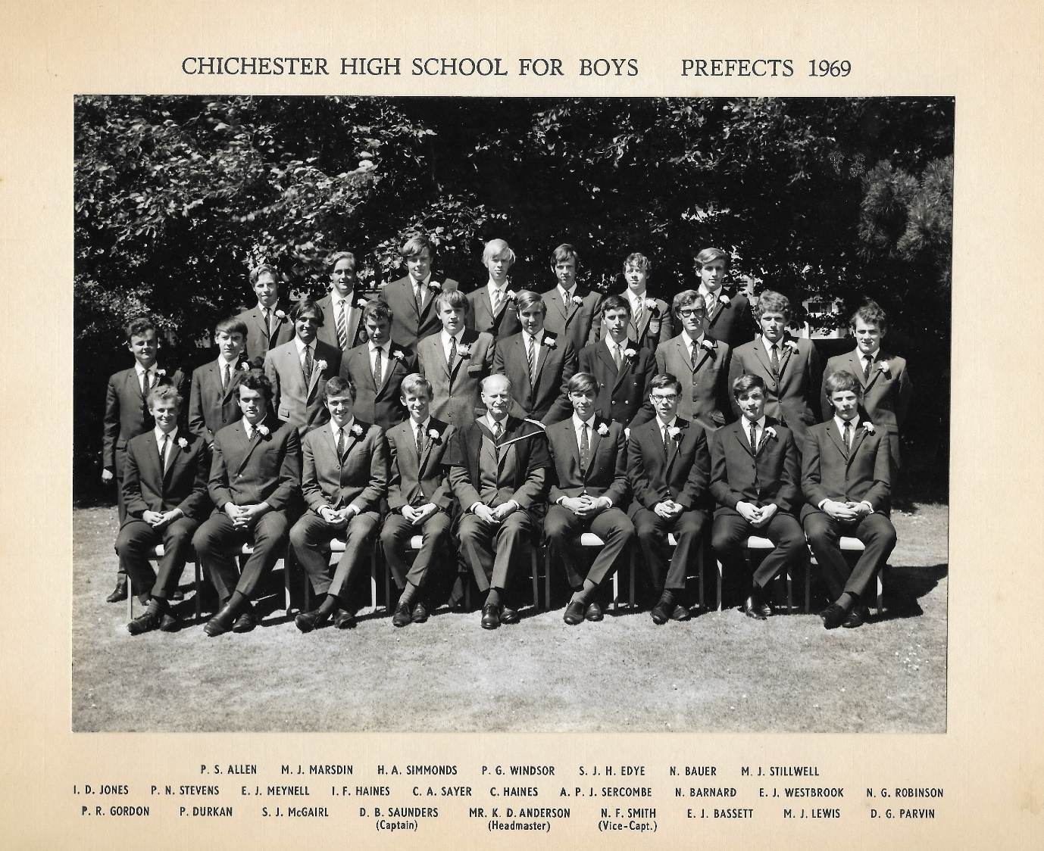

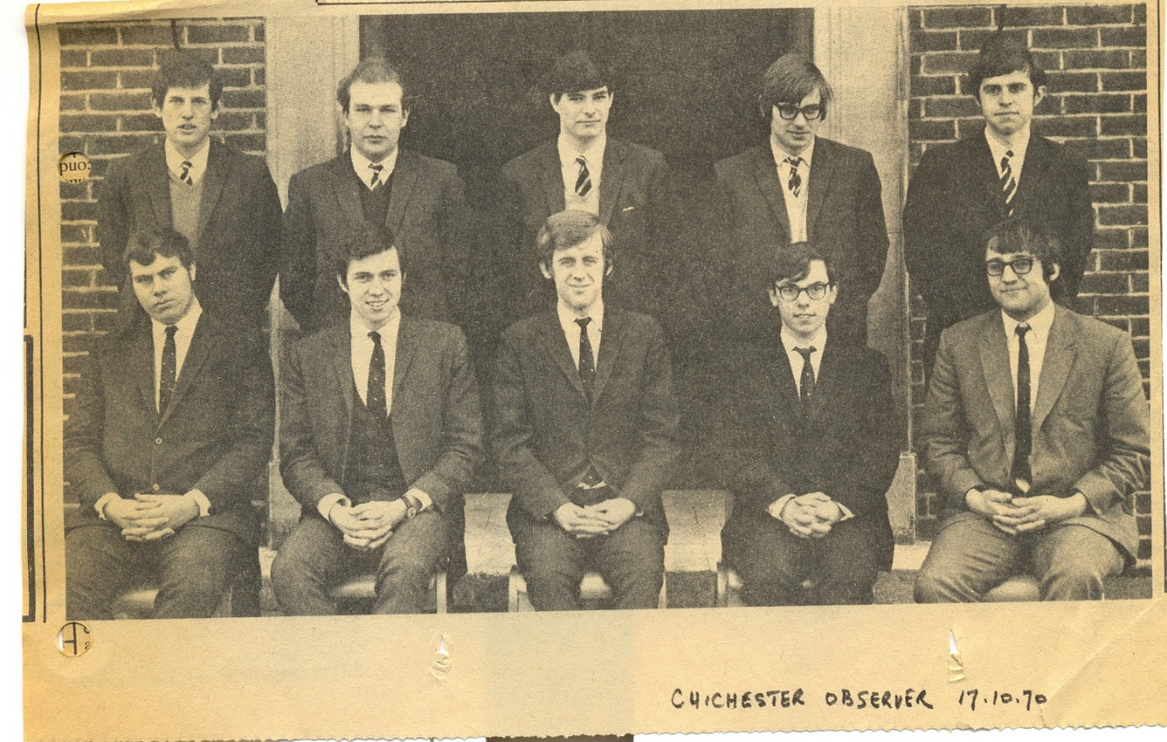

The Oxbridge one from the Chichester Observer in early 1970

